Problem - Solution Fit Template

Parameter | Details
Date | 18 June 2026
Team ID
Project Name | Book A Doctor
Maximum Marks | 2 Marks

____________________________________________________

Problem - Solution Fit Template:
The Problem-Solution Fit simply means that you have found a problem with your customer and that the solution you have realized for it actually solves the customer’s problem. It helps entrepreneurs, marketers and corporate innovators identify behavioral patterns and recognize what would work and why.

Purpose:
- Solve complex problems in a way that fits the state of your customers.
- Succeed faster and increase your solution adoption by tapping into existing mediums and channels of behavior.
- Sharpen your communication and marketing strategy with the right triggers and messaging.
- Increase touch-points with your company by finding the right problem-behavior fit and building trust by solving frequent annoyances, or urgent or costly problems.
- Understand the existing situation in order to improve it for your target group.

Canvas Diagram:

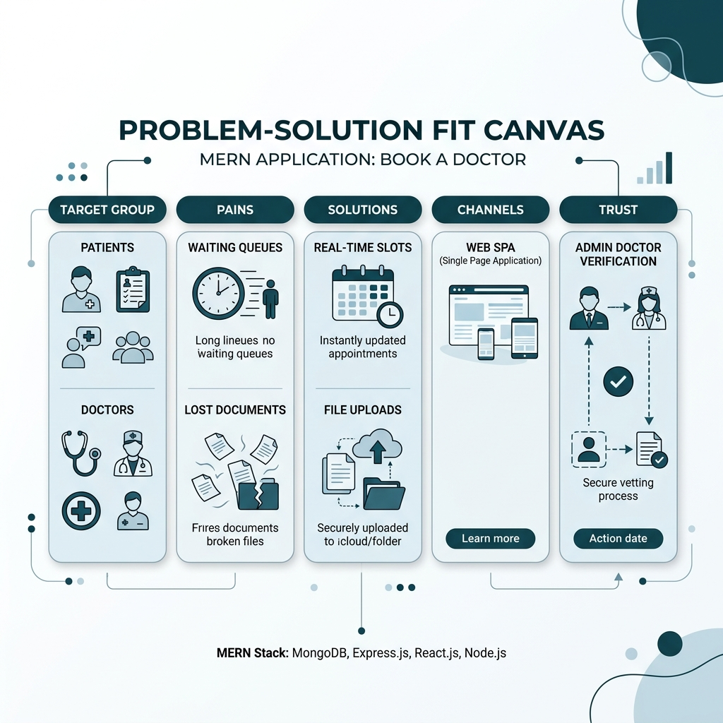
Problem Solution Fit Canvas

Canvas Details:
- Target Groups:
- Patients: Individuals seeking immediate or scheduled medical consultations with specialists.
- Doctors: Healthcare practitioners running independent clinics or hospital schedules.
- System Administrators: Operations team managing verified listings and site security.
- Existing Behavior & Triggers:
- Behavior: Patients call clinics manually, wait in physical queue lines, carry paper history files. Doctors use physical ledger books to track appointments. Admins review documents via emails.
- Triggers: Sudden illness, regular health reviews, doctor availability updates, new clinic registrations.
- Problems & Pain Points:
- Patient Pain: Uncertainty of availability, loss of medical reports, long waiting times.
- Doctor Pain: High volume of booking phone calls, calendar conflicts, lack of patient histories.
- Admin Pain: Time-consuming verification of doctors, vulnerability to fraudulent listings.
- Proposed Solutions:
- For Patients: Search engine filtered by specialty, interactive slot calendar, medical file upload.
- For Doctors: Dashboard to set available time slots and approve/reject bookings dynamically.
- For Admins: A verification panel with statistical counts and user deletion tools.
- Channels & Touchpoints:
- Responsive Web Application (Vite + React frontend SPA, Express API backend, MongoDB).
- Dashboard interfaces optimized for mobile and desktop screens.
- Trust & Security:
- Admin Approval: Only verified, approved doctor accounts are displayed in searches.
- Secure Login: Encrypted passwords (bcryptjs) and secure session tracking (JWT).
- File Isolation: Uploaded medical documents are restricted to the patient who uploaded them.

